NYSAFChaplains, Inc.
2021 Annual Report – April 24, 2022
Chief Chaplain Leon I. VanWie

Assignment: Chief Chaplain
Period: January 1, 2021 – March 31, 2021
- Attended BOD meeting on Zoom on January 31, 2021
- Sent weekly emails to membership (41 thus far)
- Dealt with numerous questions about dues notices
- Helped four chaplains write prayers and services for wakes
- Checked credentials of two members
- Helped correct “PayPal” payment link
- Participated in three Zoom meetings in search of a treasurer
  - Vetted (helped) individuals for treasurer
  - Worked with former treasurer to find a CPA to conduct an audit of our financial books from 2016 to when books would be turned over to new treasurer
  - Worked to name an Honorary Member of our Association
  - Sent membership applications to several members to pass along to neighboring chaplains who are not yet members of our association
- Coordinated arrangements for deaths of chaplains Vanessa E. "Nessy" Jones (Livingston County VFPA) and Anthony Jerome "Jerry" Ferro (Corinth)
- Attended the March 18 Zoom meeting for the NYS Fire Council
  - Prepared meeting announcement for Annual Meeting
  - Offered resources to two departments dealing with LODDs
  - Sent notices (cards, notes, letters) to individuals lifted up in email (as I hope we all do)

Period: April 1, 2021 – August 31, 2021
- Attended and led Annual meeting on Zoom on April 18, 2021
- Attended and led BOD meeting on Zoom on April 18, 2021
- Prepared databases for each regional director in Excel format
- Attempted to find a Chaplain to speak at the 20th Anniversary of 9/11 on the Maryland/Virginia state line at a worship service - someone who worked on the pile
- Sent weekly emails to membership (54 thus far)
- Participated in Regional Zoom gatherings for South Region (6/6), East (6/13), North (6/27), South East (7/25), and West (8/8)
- Attended the May 27 meeting for the NYS Fire Council and presented program on Suicide Prevention in the Fire Service
  - Prepared for Annual training conference and Memorial Service
  - Contacted 22 families/closest contacts of deceased fire chaplains inviting them to watch streaming of the Annual Memorial Service and expressing continued condolences
  - Attended Annual Training Conference and Annual Memorial Service
  - Prepared and sent refunds for 7 chaplains/department who could not attend the conference
  - Helped several chaplains write prayers and dedication services for local departments
  - Sent notices (cards, notes, letters) to individuals lifted up in email (as I hope we all do)

Period: September 1, 2021 – December 31, 2021
- Sent emails to membership (63 thus far)
- Sent and authorized the treasurer to send the refunds for the 2021 conference back to members/departments who didn’t attend the conference
- Offered prayers at 9/11 Stair Climb
- Spoke at 9/11 Memorial Service in Watertown, honoring firefighters and Fort Drum military killed in Afghanistan and Iraq since 9/11/01
- Submitted article and photos to Fire News, NYS Chiefs, and local newspaper (Watertown Daily Times) about annual training conference held August 15-18, 2022:
https://www.nny360.com/communitynews/faithperspectives/nys-fire-chaplains-convene-in-person-after-covid-delays/article_a91b62bb-d1b3-5f29-93a4-f11479b5de19.html
https://issuu.com/firenews1/docs/fire_news_new_york_state_12-21.?fr=sNWU4ZDMwNTc3
  - Attended the September 14 meeting for the NYS Fire Council in Syracuse (report is below on page 4)
  - Finalized portrait composite for Fraternal Composites (page 5)
  - Discussed with Syracuse area chaplain about setting up “Chaplain Teams” for area
  - Attended October 4th BOD meeting in Albany
  - Attended annual New York State Fallen Firefighters Memorial on October 5 at the Convention Center
  - Attended the November 18 meeting for the NYS Fire Council in Latham, NY (report is below on page 6)
  - Helped several members connect with Treasurer and Executive Secretary
  - Sent 9/11 resources to a chaplain
  - Checked on payments of dues for several chaplains
  - Connected woman with FDNY Chaplain’s Office for gift donation
  - Conducted an email vote regarding purchase of computer for Executive Secretary
  - Helped member explain “Social Member” and “Retired Chaplain” to their department

Assignment: Social Media and Website
Period: January 1, 2021 – December 31, 2021
- Prepared posts, at least one daily, on our Facebook page
- Updated Website numerous times (BOD contact info, 2021 Annual Training Conference, 2022 Annual Training Conference)

Assignment: Supply Officer
Period: January 1, 2021 – December 31, 2021
- Ordered new merchandise to sell – jacket, shirts, prayer cards, New Testament, Chaplain’s Manual)
- Filled numerous orders from conference, after receiving supplies

Assignment: Connections Committee
Period: January 1, 2021 – December 31, 2021
- The every other week or so emails to the members continue to receive many positive comments. Members feel it is a great way to keep connected and deeply appreciate prayer concerns.

Assignment: Historical Committee
Period: January 1, 2021 – December 31, 2021
- Updated the History to reflect 2021 Annual Training Conference.
- Chief Chaplain Mayo is still working on the Annual Conference summaries for 2018 and 2019.

Assignment: Liaison to NYSAFChiefs
Period: January 1, 2021 – December 31, 2021
SIZE UP
- Wrote and submitted 2021 Issue 2 “The Most Important Part of Receiving an Award”
- Wrote and submitted 2021 Issue 3 - Memorial Address delivered at Chief’s Show
- Wrote and submitted 2021 Issue 4 - “Attaboys”, “Attagirls” and Confirmations!

2021 Chief’s Show Memorial Service–(July 15 at 10 AM [Marriot's Finger Lakes Ballroom])
Invocation Kenneth W. Palmer
A Lesson from the Old Testament Thomas F. With
Moment of Recognition Richard G. Bolster
Intertestamental Reading Samuel P. Lundy
A Lesson from the New Testament Eugene A. Preston
Memorial Address Leon I. VanWie
Benediction Spencer P. Kennedy

2022 Chief’s Show Memorial Service–(Scheduled for Thursday, June 16 at 10 AM)
Invocation Samuel P. Lundy
A Lesson from the Old Testament Kenneth W. Palmer
Moment of Recognition Barrie-Lyn Foster
Intertestamental Reading Eugene A. Preston
A Lesson from the New Testament Spencer P. Kennedy
Memorial Address Leon I. VanWie
Benediction Thomas E. Doyle

Assignment: Email Group of the NYSAFChaplains, Inc.
Period: January 1, 2021 – December 31, 2021
278 individuals interested in fire chaplaincy receive the emails.
18 emails have been sent out

Sincerely,
Rev. Leon I. VanWie, Chief Chaplain
END

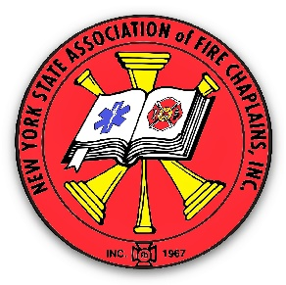
NYS Association of Fire Chaplains, Inc.
September 14, 2021
Report to NYS Fire Council Meeting
Syracuse, NY

37 Chaplains attended the Annual Training Conference that was held in Watertown, August 15 – 18, 2021. Also 13 spouses attended in person.

The Crisis Intervention and Psychological First Aid training was also offered through a streaming service. 7 participated in the entire training, and 5 participated in some of the online training.

The annual memorial service was also streamed and about 25 watched the service. I apologize for not having a specific number. The streaming service offered a direct link, which we have accurate numbers for, however, there was also a mirroring program through Facebook and the data was not consistent.

Our next Board of Directors’ meeting will be held in Albany on October 4th and will coincide with the NYS Fallen Firefighter’s Memorial at the NYS Convention Center on October 5th.

The 2022 Annual Meeting and Training Conference will be held April 24 – 27 in East Greenbush, NY. Chaplain Thomas With will be our host chaplain.

Sincerely,
Chief Chaplain Rev. Leon VanWie

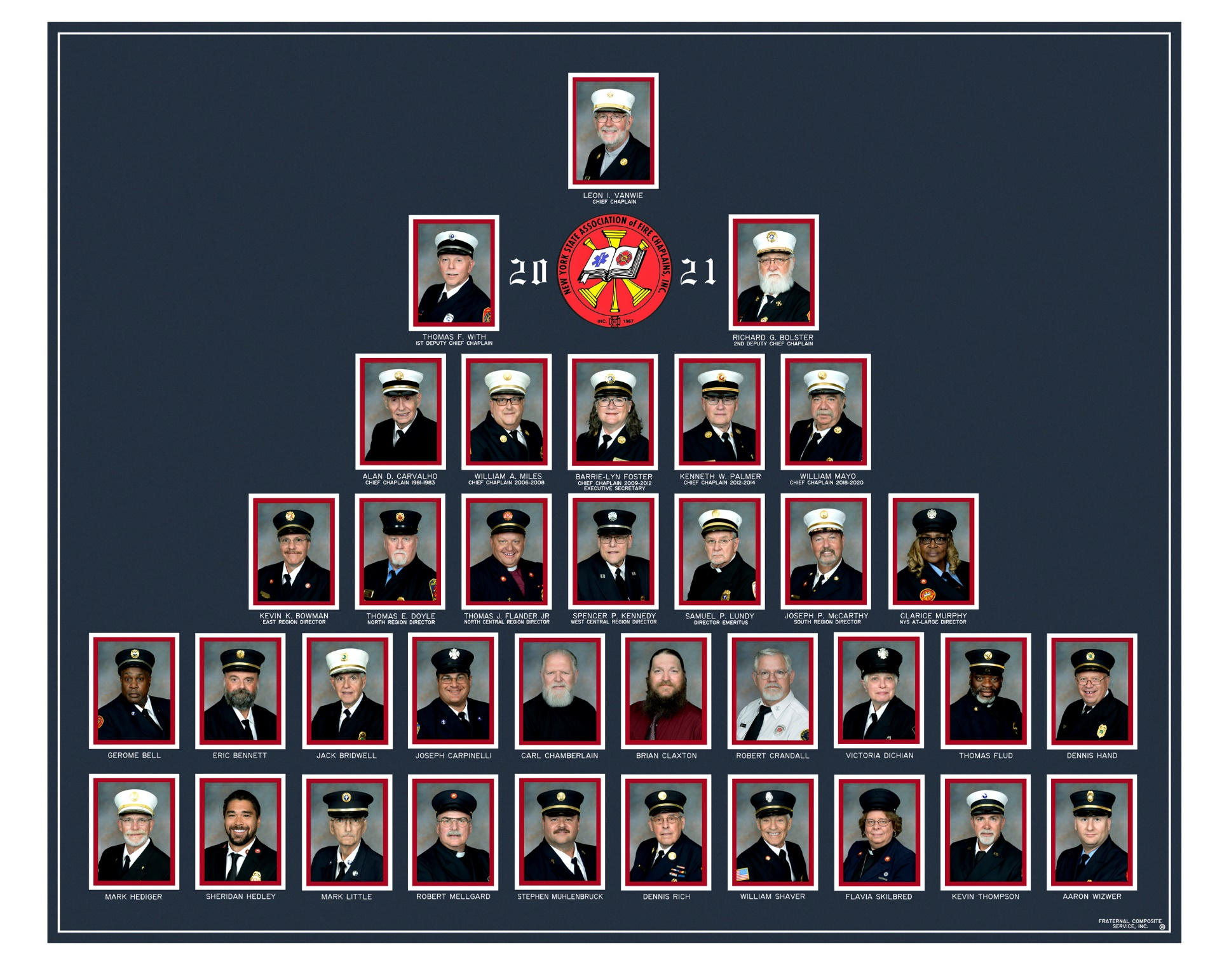

NYS Association of Fire Chaplains, Inc.
November 18, 2021
Report to NYS Fire Council Meeting
Latham, NY

The NYS Fallen Firefighter Memorial on October 5, 2021 was very well done – very meaningful! A great job to all who organized it and participated!

Our next Board of Directors’ meeting will be held at the NYS State Training Academy at Montour Falls on February 6-7, 2022. The option was presented to the BOD for either a Zoom meeting or an in-person gathering and the desire for in-person was overwhelming – looking for “normal”.

The 2022 Annual Meeting and Training Conference will be held April 24 – 27 in East Greenbush, NY. Chaplain Thomas With will be our host chaplain.

Sincerely,
Chief Chaplain Rev. Leon VanWie

