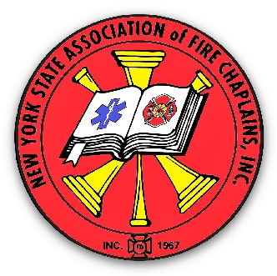
New York State
Association of Fire Chaplains, Inc.
APPLICATION FOR MEMBERSHIP
(Revised August 28, 2020)

Title: _______ First Name: ______________ MI: ______ Last Name: ______________
Ordained ____ Lay ____ (check one) Spouse’s Name: ________________________
Address: ______________________________________________________________
City: ______________________ State: ______ Zip Code +4 ________________
County _____________________ Religious Affiliation __________________________
Fire Department or Organization: ___________________________________________
Home Telephone: ___________________ Work Telephone: __________________
Cell Telephone: ____________________ Fax: ____________________
Email Address: _________________________________________________________

This application MUST be accompanied by the following:
1) A letter of appointment from the Chief or President of the sponsoring Fire or EMS Organization.
2) You must provide a letter of reference from your church or religious affiliation, also known as a letter of ecclesiastical support.
3) A passport size photo, which will be returned with membership photo ID Card.
4) A check in the amount of $25.00 made payable to “NYSAFC, Inc.” (which includes your first year’s dues – the membership year is the calendar year).
FAILURE TO PROVIDE THE ABOVE WILL DELAY PROCESSING
Mail the above with this application to: NYSAFC, Inc. Chap. Barrie Lyn Foster, Executive Secretary, 741 Clark Street Rd, Cayuga, NY 13034-2113
(Also, please include copies of certificates for training you have, for example NIMS, CISM, CISD, HAZMAT, Etc.)

