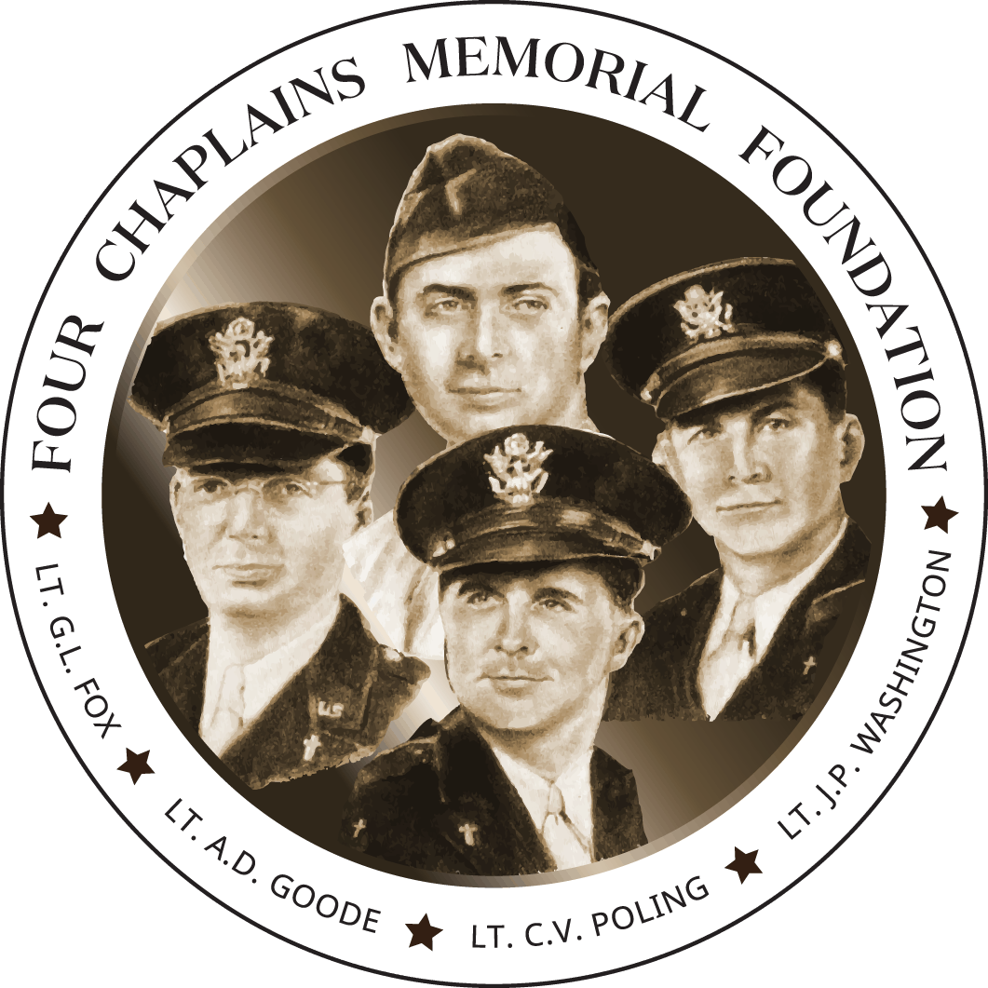

New York State Association of Fire Chaplains
Annual Conference 2022

Theme of Conference: “Four Chaplains”
Dates of Conference: Sunday April 24th Arrival
Wednesday April 27th Departure at Noon
Place of Conference:
Comfort Inn and Suites East Greenbush
99 Miller Road, Castleton, NY (Same as 2019 Conference)
More information to follow!!
Point of Contact: Thomas With, tomwith@hotmail.com

